INNOCENS
Innovation & Entrepreneurship
SURVEY FOR STUDENTS
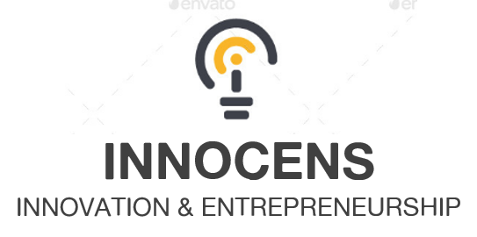

University:

What are you studying?

Male/Female?
- Male
- Female

Age

1. Do you get any training course on entrepreneurship during your university degree?
- Yes
- No
- I don't know

2. Are you interested in learning more about innovation and entrepreneurship, as taking 1 or 2 courses on this topic?
- Yes
- No
- I don't know
3. Have you ever thought about undertaking a business instead of working as an employee?
- Yes
- No

4. Do you have any business idea?
- Yes
- No

5. If yes, would you like to tell us more about your idea?

6. Do you think your university currently provides the required tools and assessment to be entrepreneur?
- Yes
- No
- I don't know

7. What are the main difficulties to start an innovative startup in your country?
Please use the scale from 1 to 6 (1 - most important, 6 - less important ). Do not repeat the same scores.
- 1. Lack of training
- 2. Access to funding
- 3. Risk aversion
- 4. Country regulation
- 5. Insufficient capacity to innovate
- 6. Building a team
- Other:

8. What would you say are the most important skills to be an entrepreneur?
- To be a leader
- Team work
- Risk taker
- Creativity
- Technical skills
- Sales
- Design
- Other:
9. Have any of your close relatives undertaken a business?
- Yes
- No
- I don't know

10. Could you identify a person in your university that would help you in the creation of a startup?
- A professor
- Another member of the staff
- I don't know
- Other:

11. From 1-low to 5-high, is it a good idea that your university has an organization with competent staff who can help students in entrepreneurial projects (such as creating a startup)?

