INNOCENS
Innovation & Entrepreneurship
SURVEY FOR COMPANIES
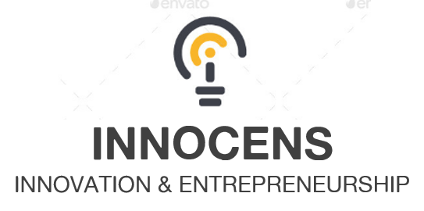
Company:
Position:
Country:

1. Do you currently collaborate with universities?
- Yes
- No
- I don't know

2. If yes, would you like to tell us more about this collaboration?

3. Are you currently doing any Research & Development activities in your company?
- Yes
- No
- I don't know

4. Do you usually hire employees among university graduates?
- Yes
- No

5. From 1 to 5, do you think the university is a good source of talent?
- 1
- 2
- 3
- 4
- 5

6. Do you think universities currently provide students with with sufficient training on entrepreneurship and business development?
- Yes
- No
- I don't know

7. What new topics do you think universities should include in their curricula?

8. What are the main difficulties to start an innovative startup in your country?
Please use the scale from 1 to 6 (1 - most important, 6 - less important ). Do not repeat the same scores.
- 1. Lack of training
- 2. Access to funding
- 3. Risk aversion
- 4. Country regulation
- 5. Insufficient capacity to innovate
- 6. Building a team
- Other:

9. What would you say are the most important skills to be an entrepreneur?
- To be a leader
- Team work
- Risk taker
- Creativity
- Technical skills
- Sales
- Design
- Other:

10. What are the main difficulties in university-industry cooperation?
- Policy
- Regulations
- Time
- Funding
- Benefit
- Interests
- Other:

