INNOCENS
Innovation & Entrepreneurship
SURVEY FOR UNIVERSITIES
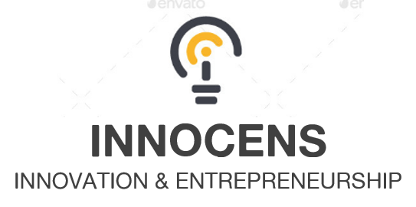

University/Partner

1. Is there a unit in charge of innovation & entrepreneurship?
- Yes
- No
- I don't know

2. How many employees are working as mentors for new entrepreneurial projects?

3. Is there currently any training course in innovation & entrepreneurship?
- Yes
- No
- I don't know

4. Is there any organized cooperation with industry or business?
- Yes
- No

5. How many startups have been created in the last 3 years?

6. How many technology transfers have been done in the last 3 years?

7. For Q5 and Q6, in which sectors?

8. Do you have a business incubator inside the university campus?
- Yes
- No

9. If yes, how many startups are being incubated at the university?

10. Has your university a major role in your local entrepreneurial ecosystem?
- Yes
- No
- I don't know

11. Is there any business idea/startup competition currently in the university?
- Yes
- No
- I don't know

12. Are there multidisciplinary activities currently being developed in the university?
- Yes
- No
- I don't know

13. Does the university facilitate access to public/private funding for its potential entrepreneurs?
- Yes
- No
- I don't know

14. What are the main difficulties to start an innovative startup in your country?
Please use the scale from 1 to 6 (1 - most important, 6 - less important ). Do not repeat the same scores.
- 1. Lack of training
- 2. Access to funding
- 3. Risk aversion
- 4. Country regulation
- 5. Insufficient capacity to innovate
- 6. Building a team
- Other:

15. What are the main difficulties in university-industry cooperation?
- Policy
- Regulations
- Time
- Funding
- Benefit
- Interests
- Other:

16. What would you say are the most important skills to be an entrepreneur?
- To be a leader
- Team work
- Risk taker
- Creativity
- Technical skills
- Sales
- Design
- Other:

17. Is there anything else you would like to add?

